Implementing a Full CI/CD pipeline

Chapter 5-Continous Delivery

<https://learn.acloud.guru/course/93e6884d-ac98-49b6-a9cd-5e357d2dbb41/dashboard>

Project repo <https://github.com/linuxacademy/cicd-pipeline-train-schedule-cd>

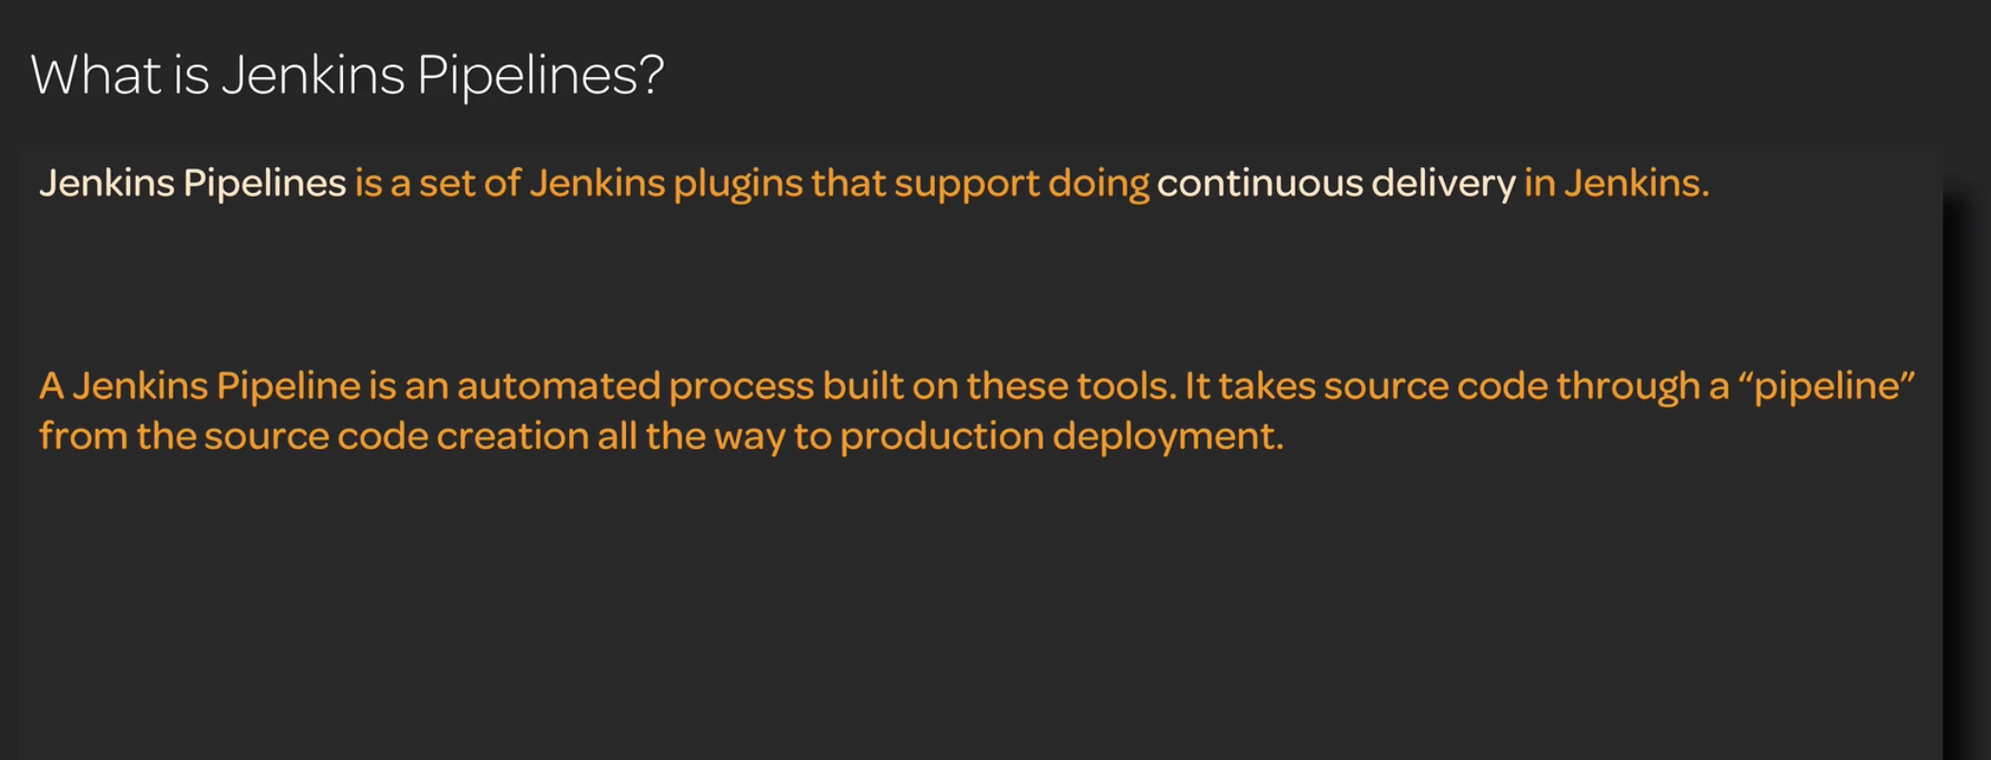

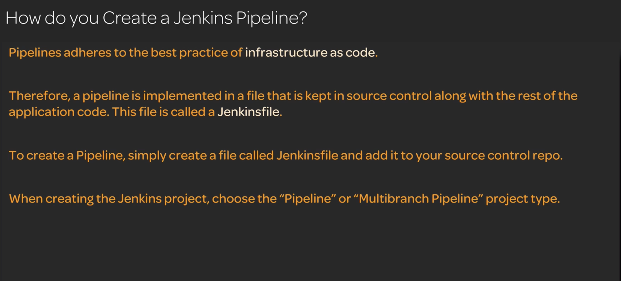

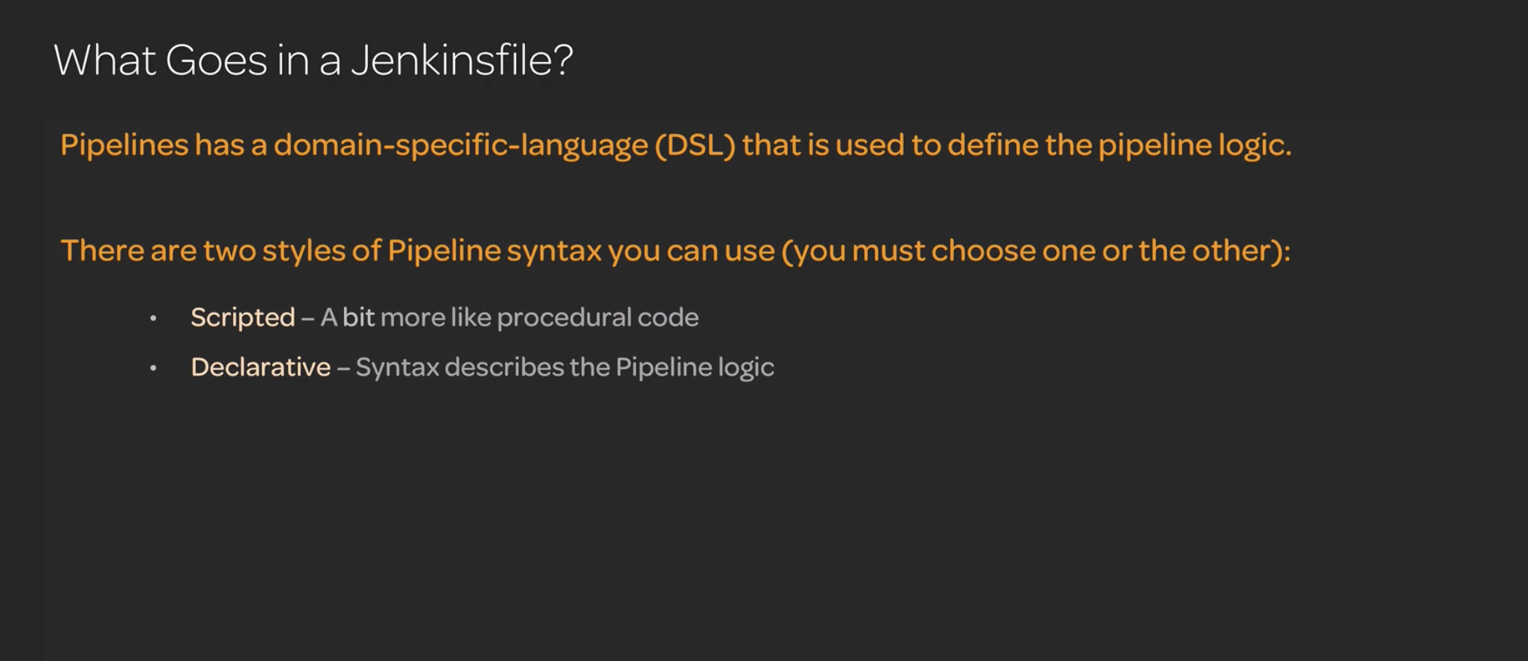

Stages vs steps – stages are series of steps to complete a larger stage

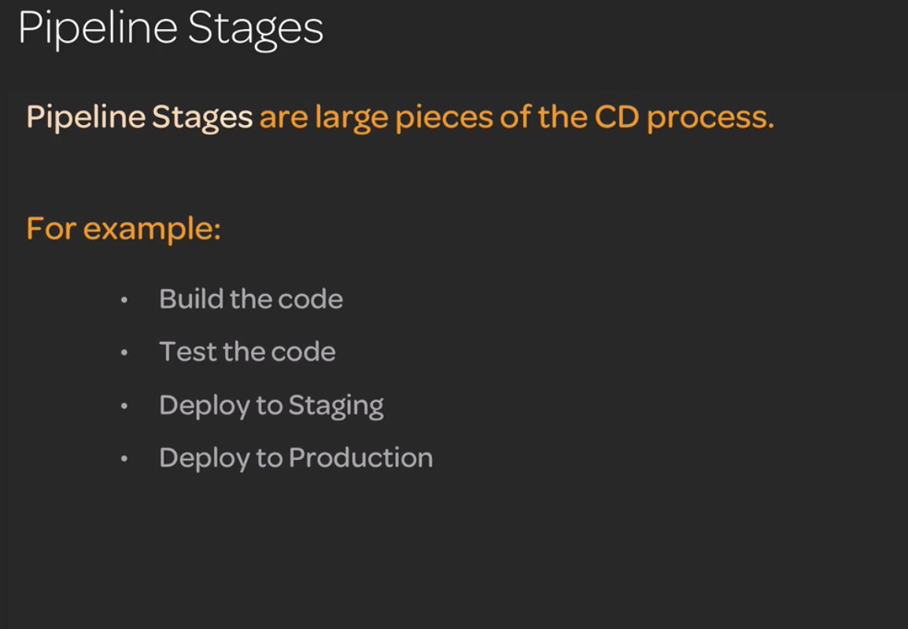

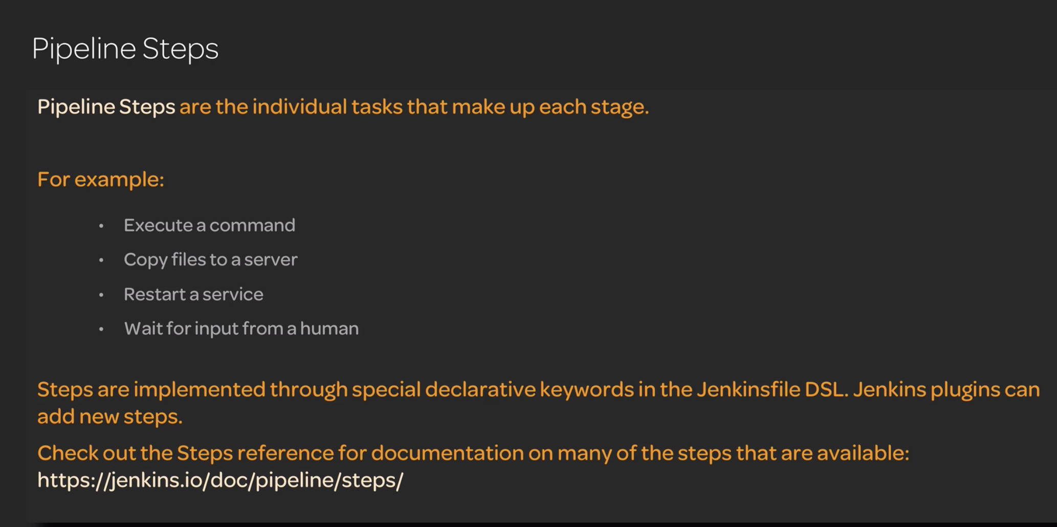

Jenkinsfile for cloud guru project

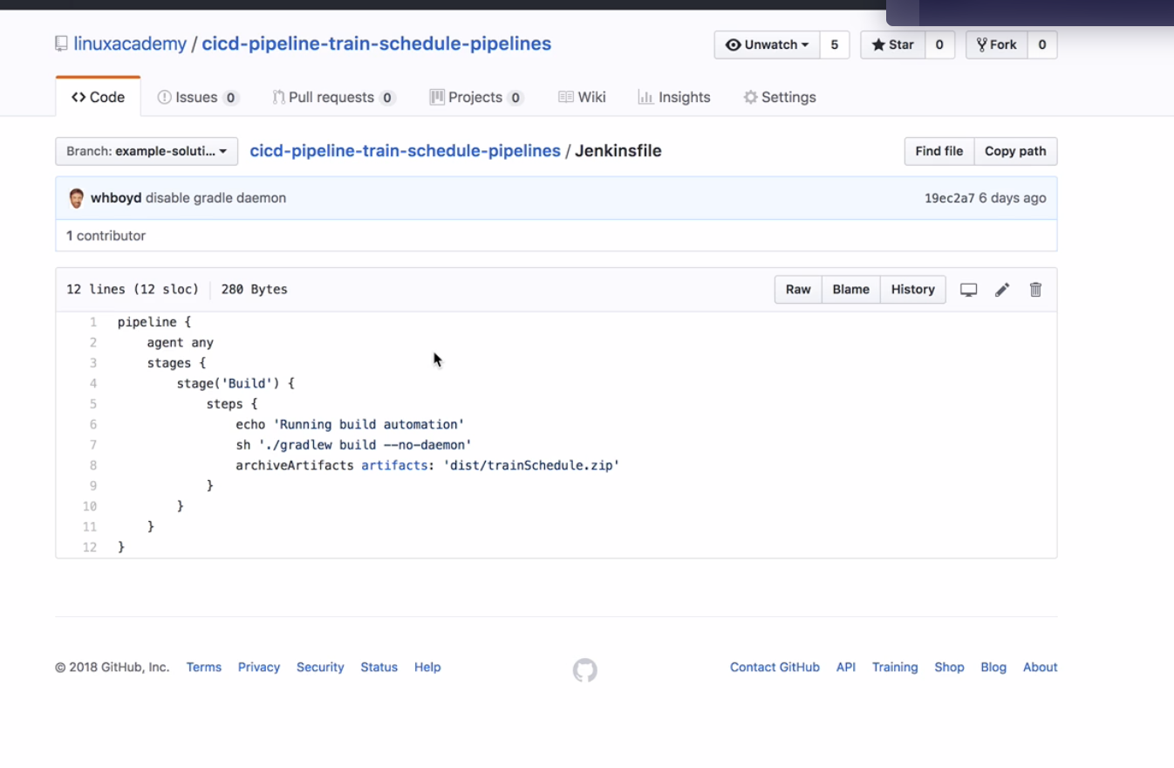

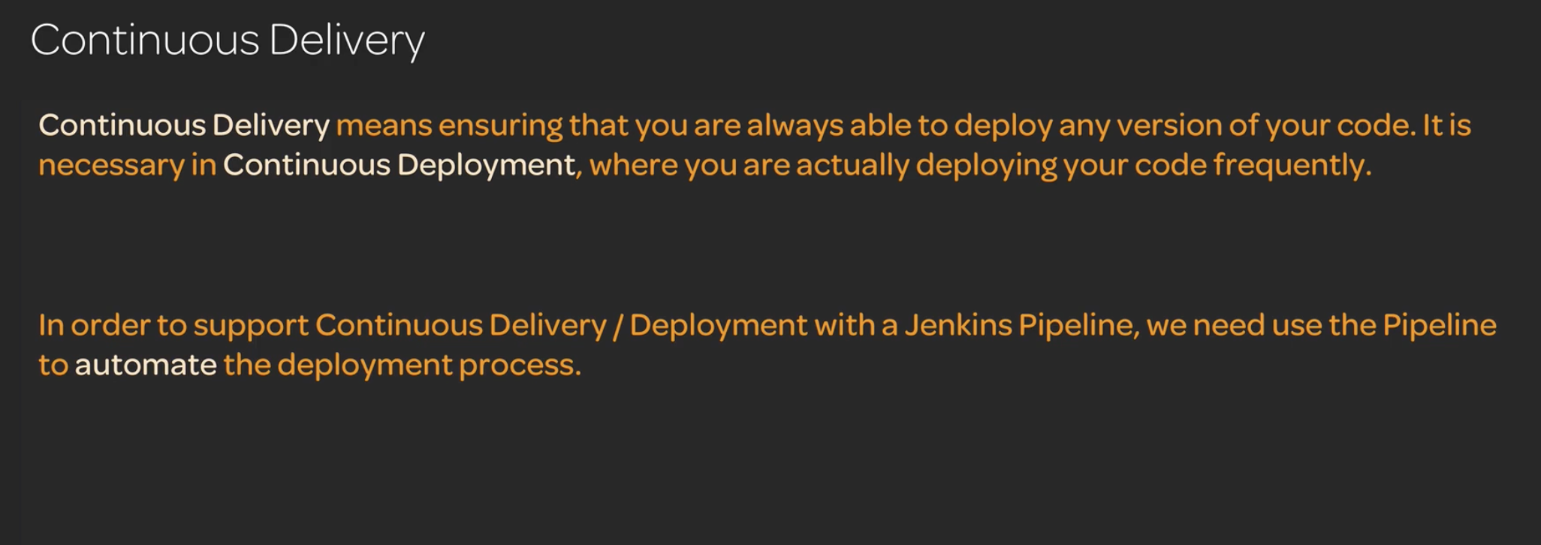

Deployment with Jenkins Pipeline

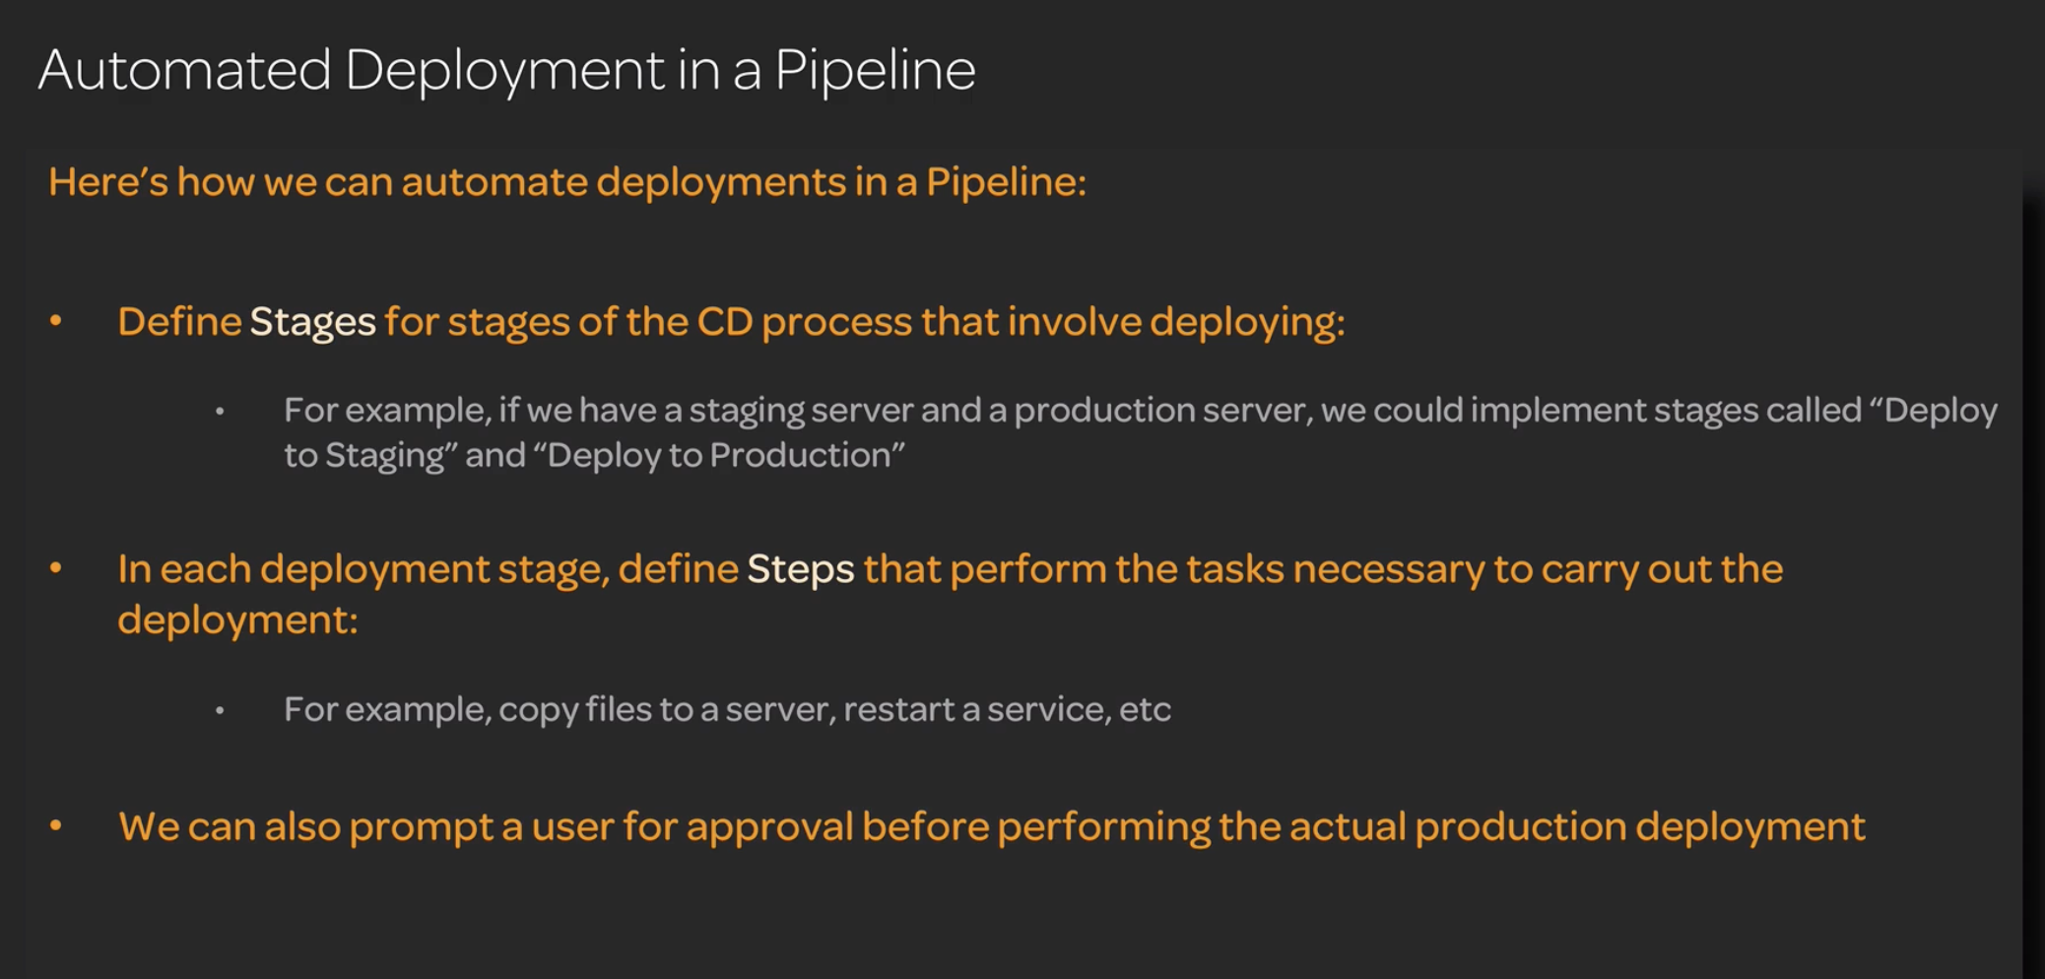

<https://github.com/linuxacademy/cicd-pipeline-train-schedule-cd>

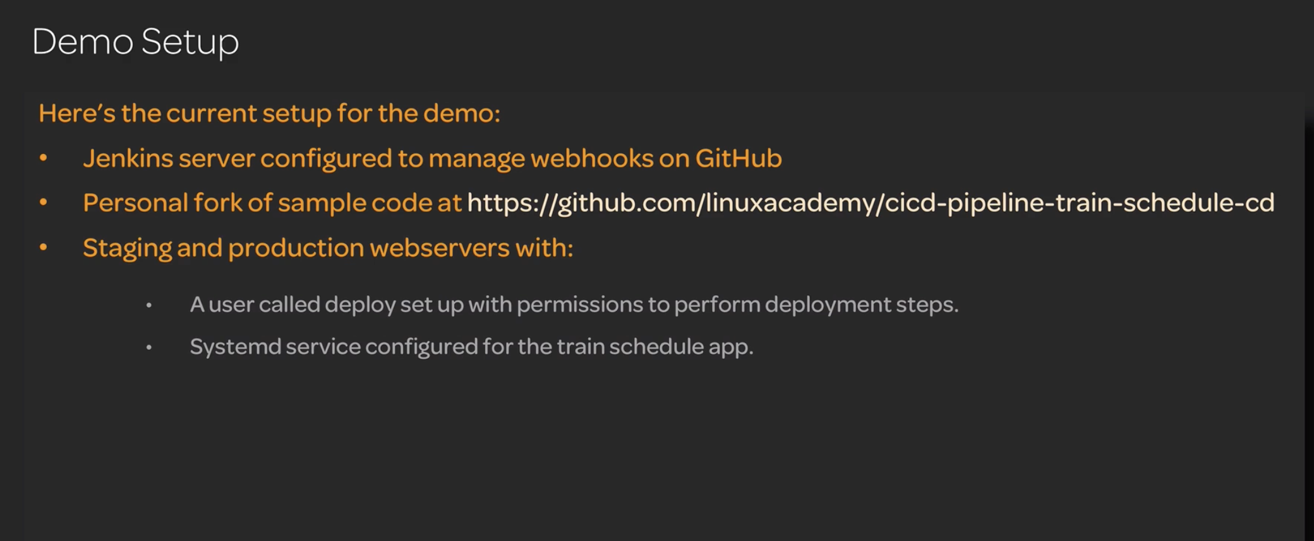

Installing Publish over ssh plugin to copy files from staging to prod server

1.

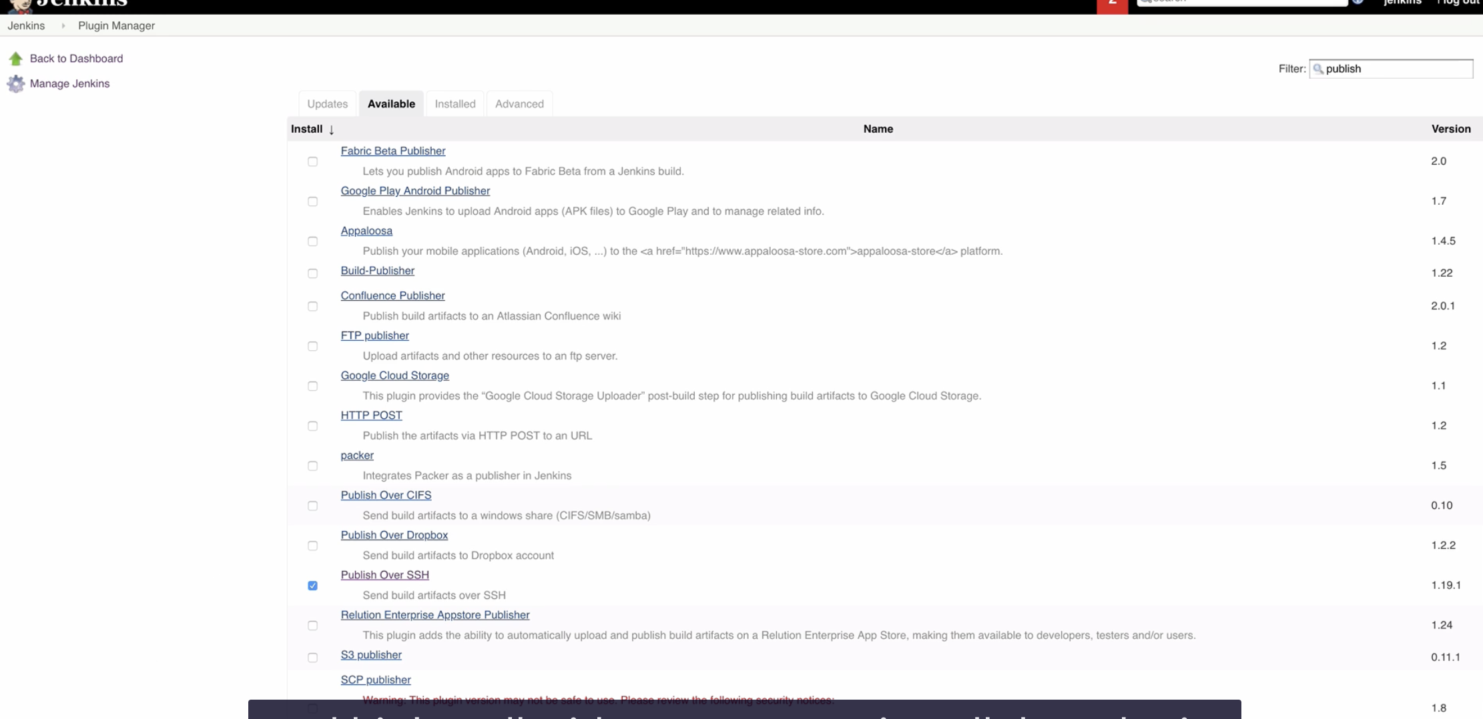

2. Configuring the plugin inside Jenkins>ManageJenkins>configuration

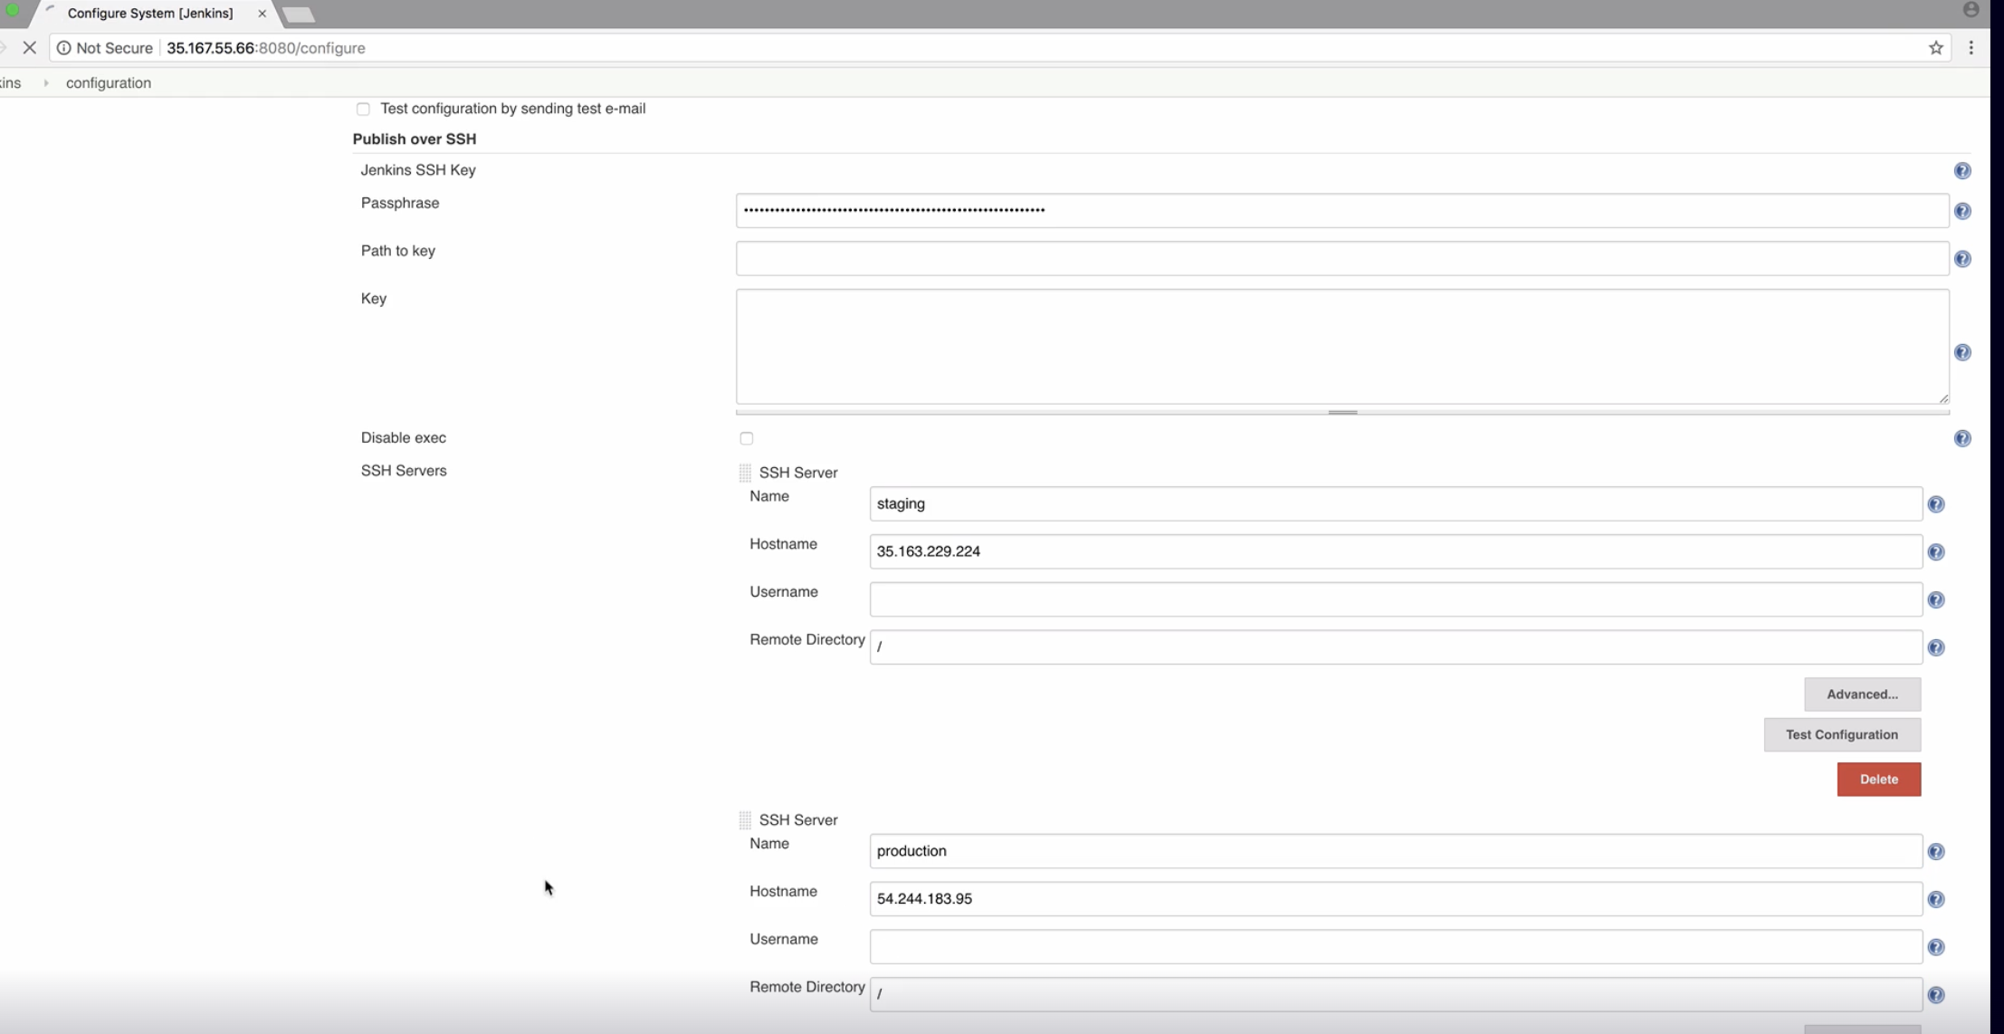

3.Create a user in both staging and prod servers so Jenkins can loginto those servers using this user credentials

4. Add the credentials of the created user in the Jenkins>Credentials>system>Global Credentials

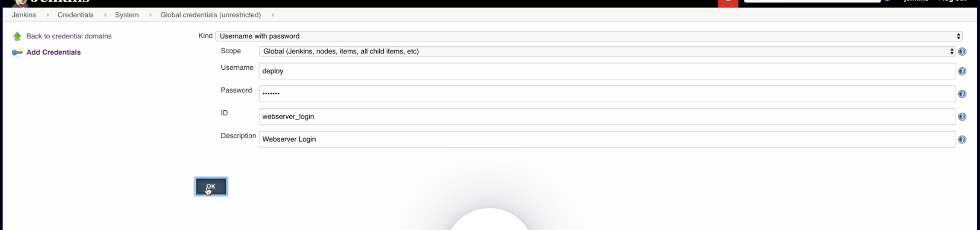

Here webserver_login is a reference to the credentials so we can use in the Jenkinsfile by calling its id

5. Create a Multibranch pipeline and Branch sources github and provide the credentials of your github account ie username and generate a github access token so the Jenkins can access your github API just like the webhook integration {refer webhook integration with Jenkins}

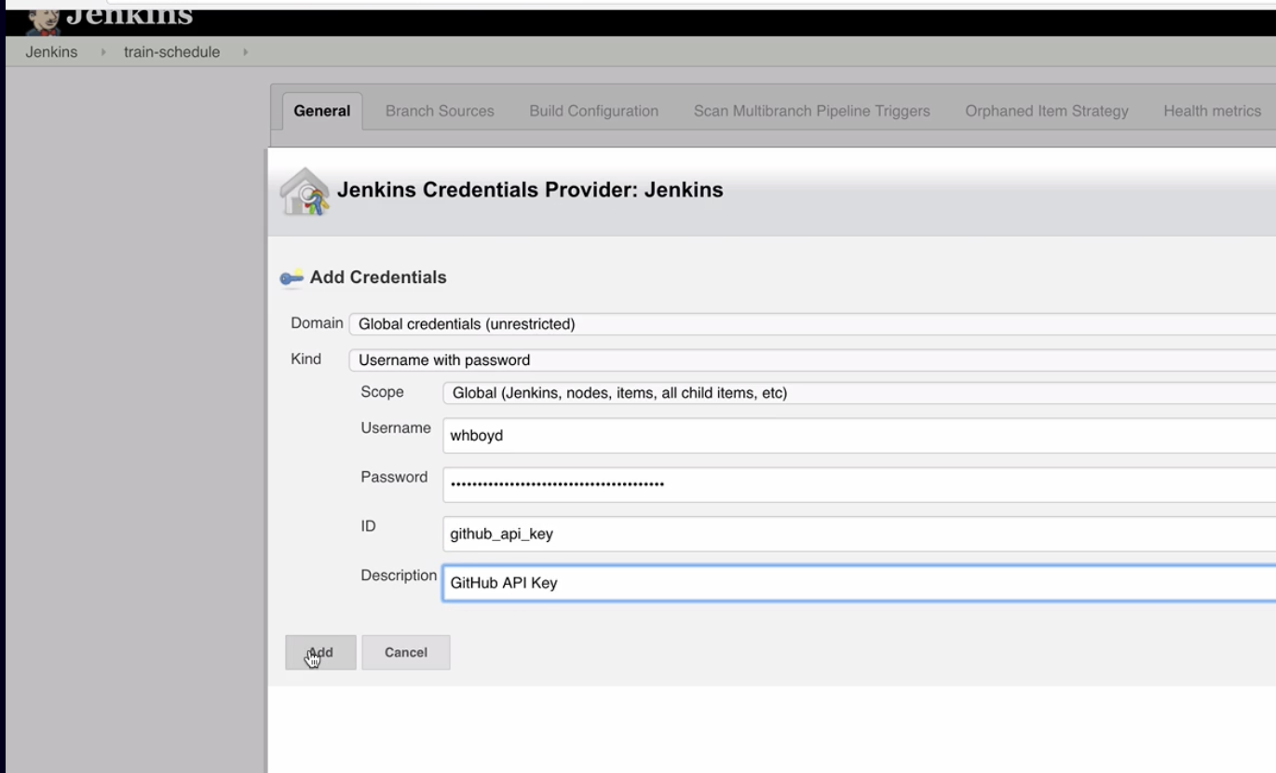

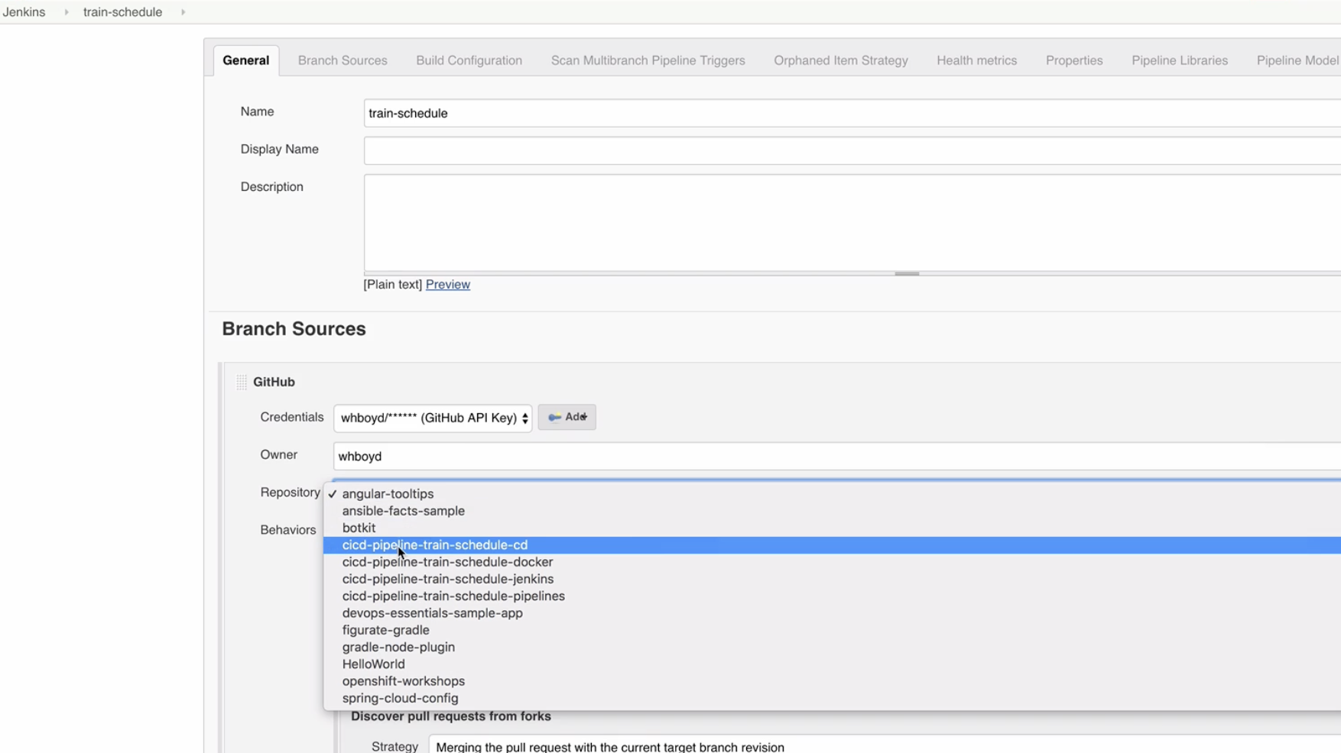

6.Selecting the right repository and save

7. Create a Jenkinsfile in github repo and write the pipeline and stages as below {available in the example-solutions branch} also creating a txtfile in localrepo >Jenkins>pipeline>Jenkinsfile(chp5-continous delivery)

Hands on Lab 1 implemented above slides

Scenario

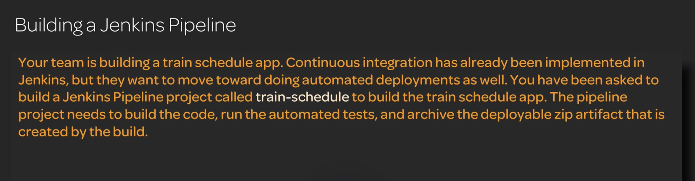

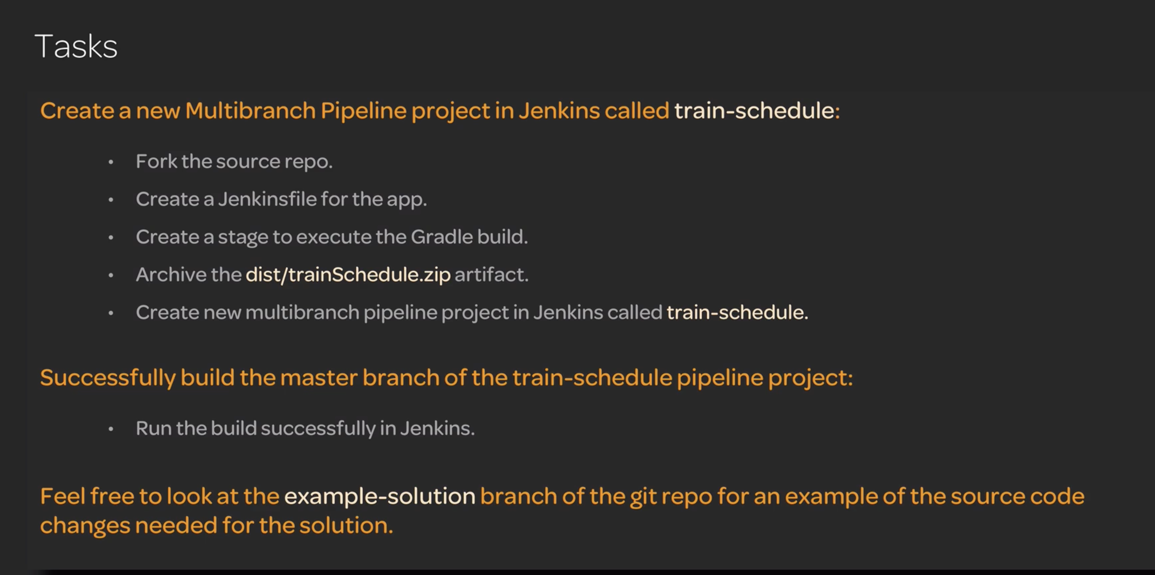

Hands On lab2 implemented above

